**Workshop3 Image Detection**Yolo: You Only Look Once!

1. Run the Jupyter notebook YoloV8.ipynb using different YoloV8 models and parameters over the provided images and then choose your own images of the Internet that have cars, motorcycles, etc and show the results. **Bibiana - Con esto responder las preguntas de más abajo**

**yolov8n:**

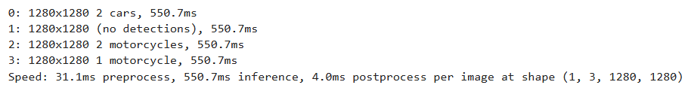

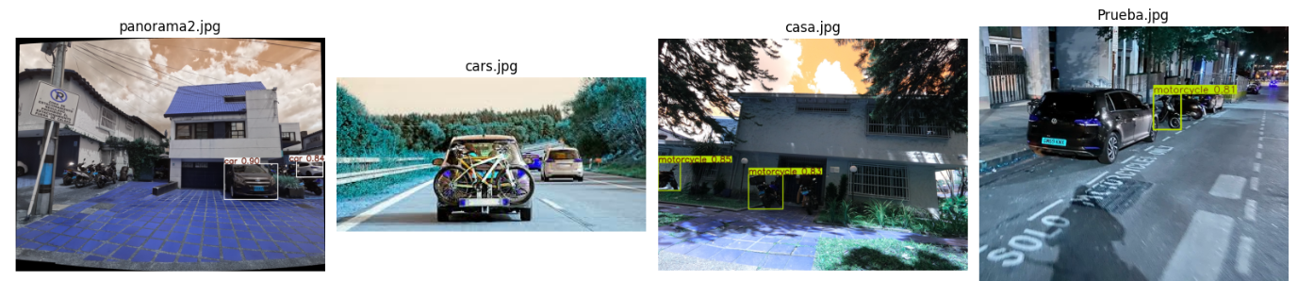

**yolov8s:**

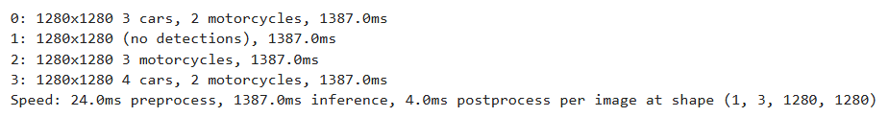

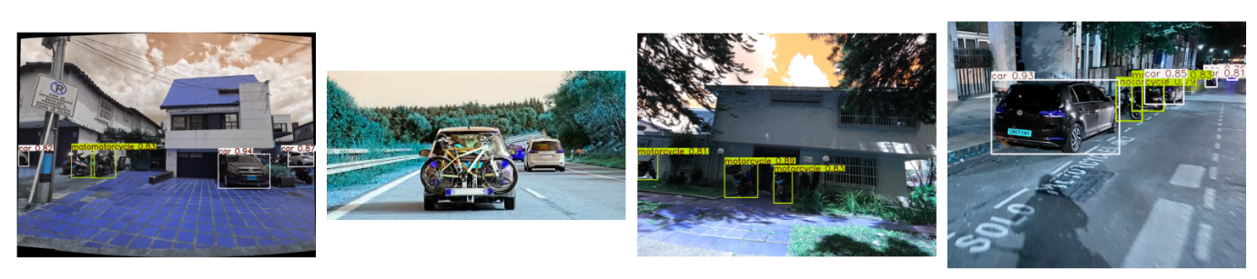

**yolov8m:**

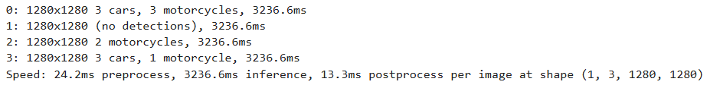

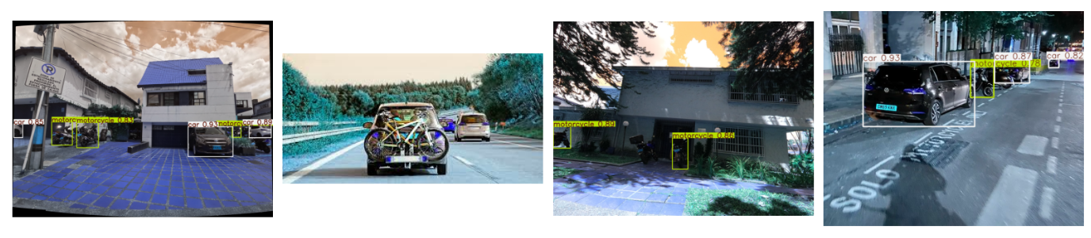

**yolov8l:**

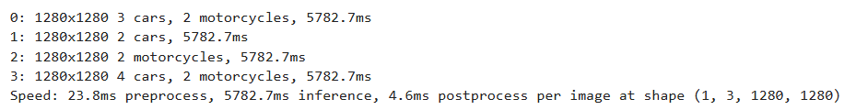

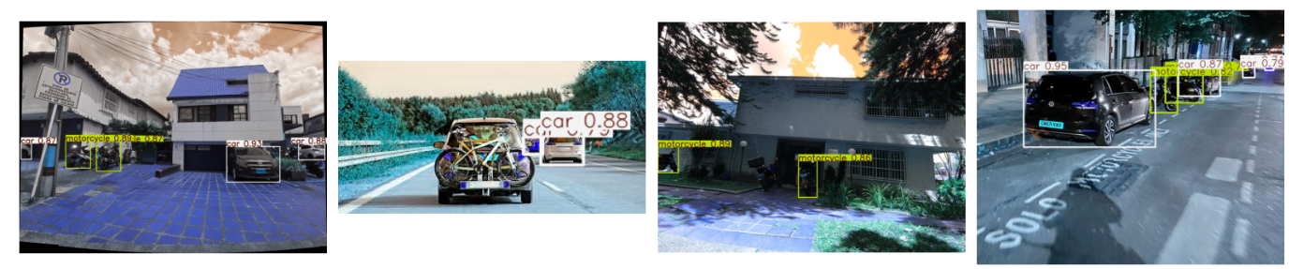

**yolov8x:**

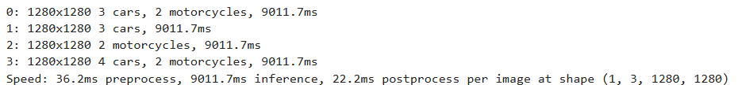

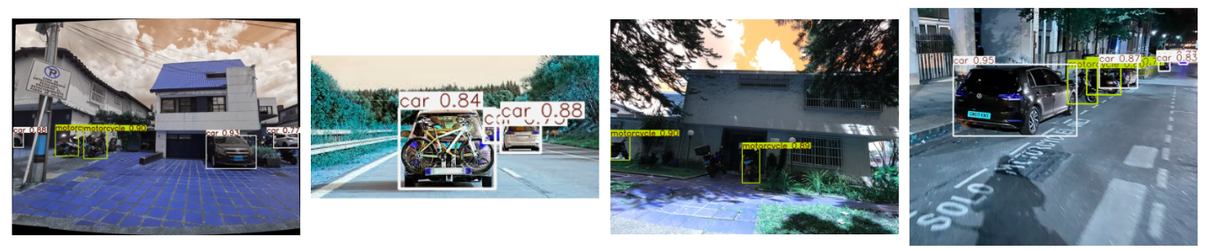

1. Use the script Yolo_Potholes.ipynb in Kaggle/Collab and train a Yolo V8 model, pick different versions of Yolo V8, nano to Xlarge and compare the results, also compare one trained model with the best model and create and download the video of the inference. Download this dataset from: <https://www.kaggle.com/datasets/farzadnekouei/pothole-image-segmentation-dataset> **Emanuel**

**Labels for batch 0:**

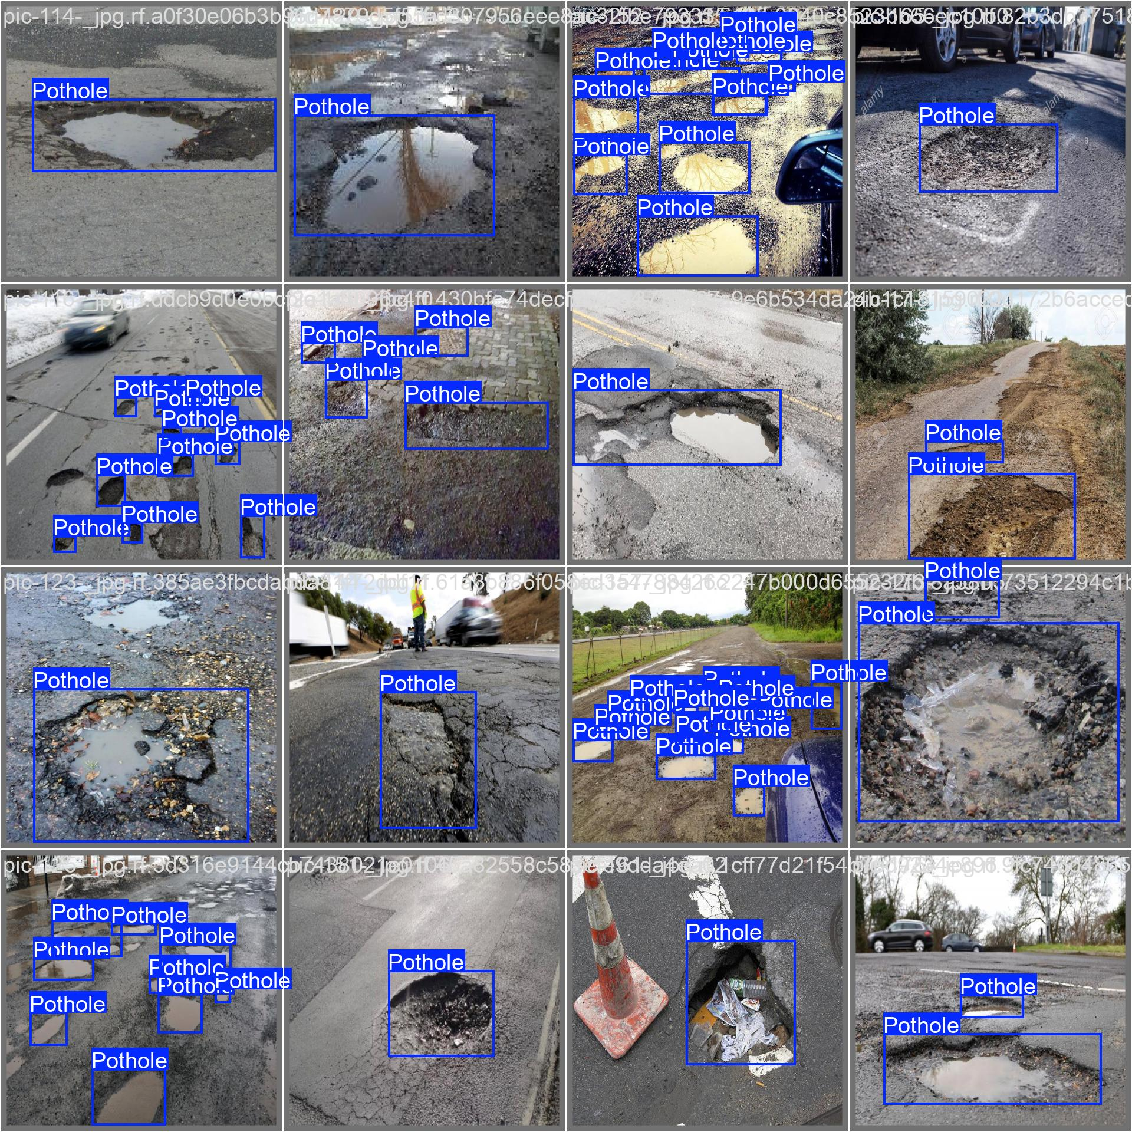

Results using same default configuration for all the models:

epochs=10,

imgsz=640,

batch=32,

optimizer='auto',

lr0=0.0001, # Initial learning rate

lrf=0.01, # Final learning rate (lr0 * lrf)

dropout=0.25, # Use dropout regularization

device='cuda:0', # Device to run on, i.e. cuda device=0

seed=42

| **Model** | **box_loss** | **cls_loss** | **dfl_loss** | **Precision** | **Recall** | **mAP50** |
| --- | --- | --- | --- | --- | --- | --- |
| nano | 1.163 | 1.088 | 1.229 | 0.656 | 0.702 | 0.721 |
| small | 1.242 | 1.025 | 1.303 | 0.74 | 0.642 | 0.72 |
| medium | 1.308 | 1.102 | 1.409 | 0.705 | 0.675 | 0.695 |
| large | 1.528 | 1.599 | 1.72 | 0.603 | 0.46 | 0.455 |
| xlarge | 1.621 | 1.744 | 1.83 | 0.513 | 0.512 | 0.503 |

**Nano**

**Random predictions:**

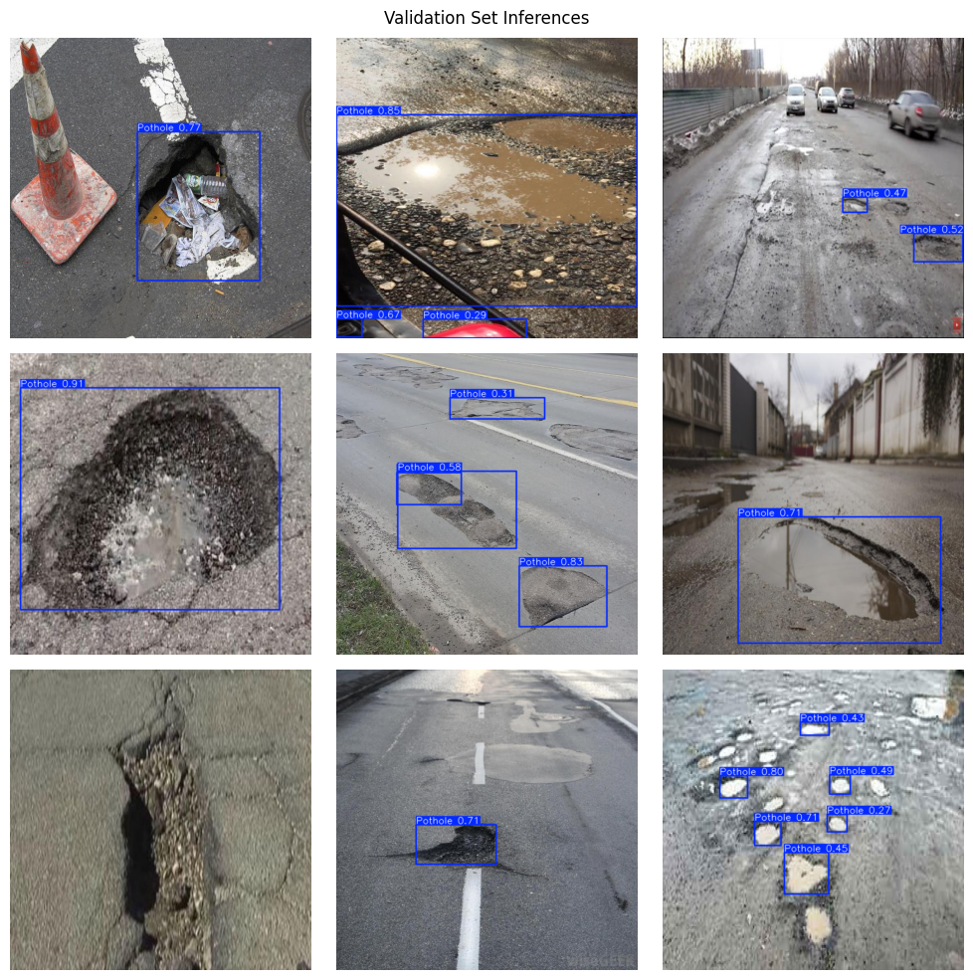

**Predicted values for batch 0:**

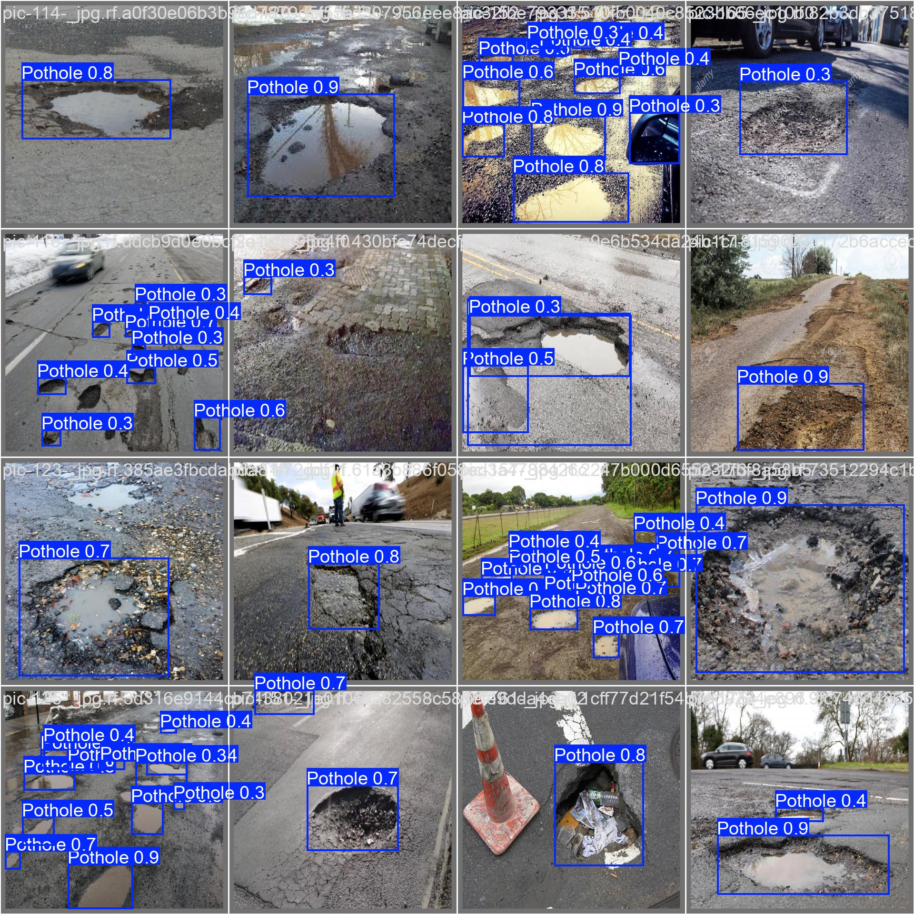

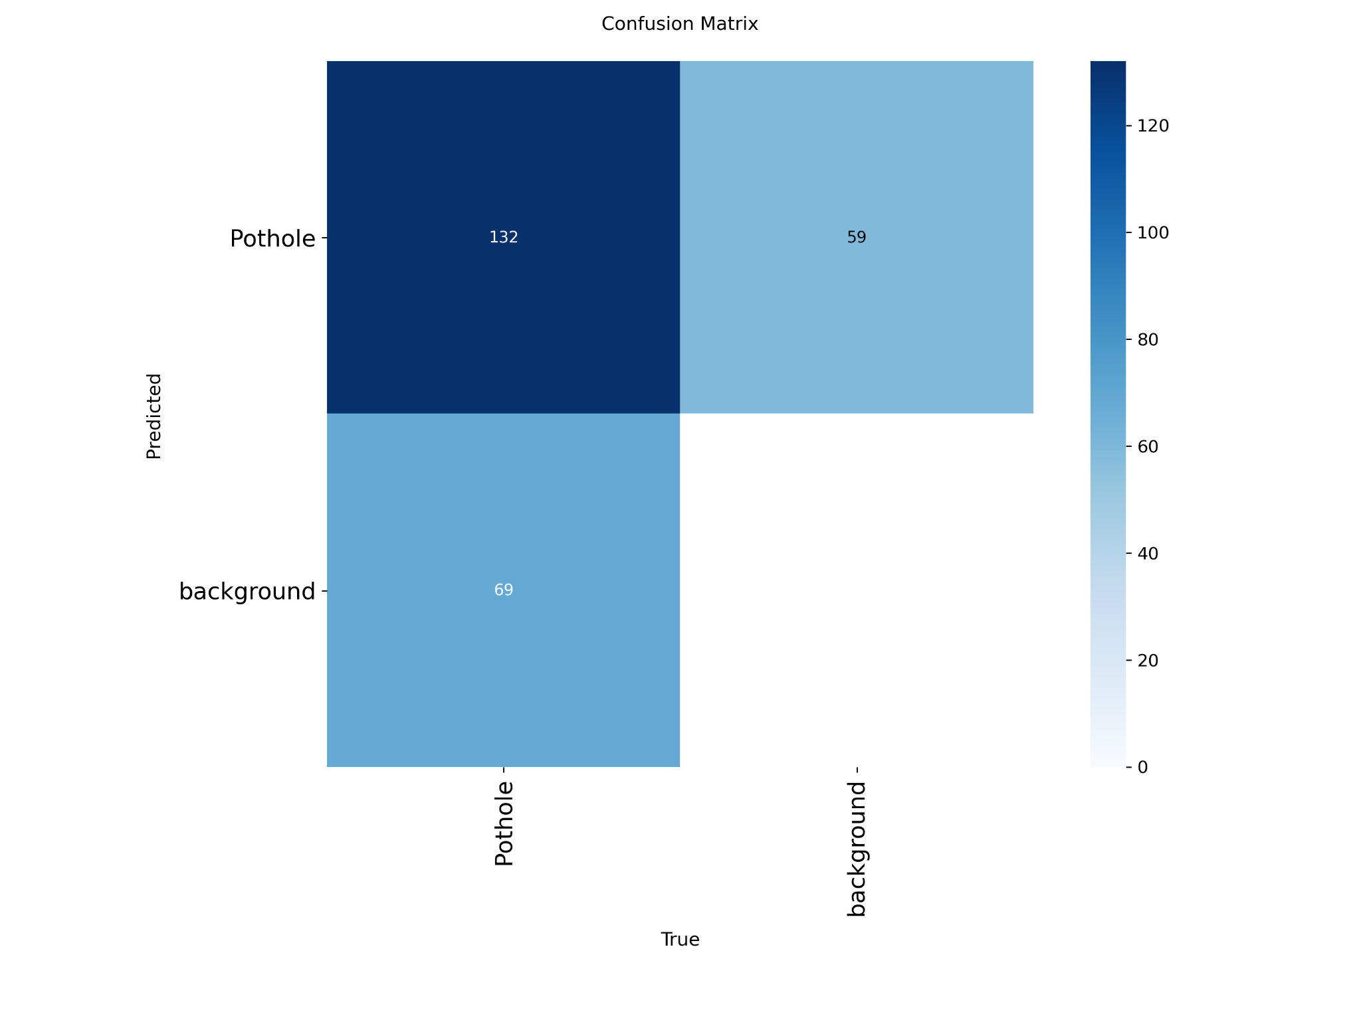

**Small**

**Random preds:**

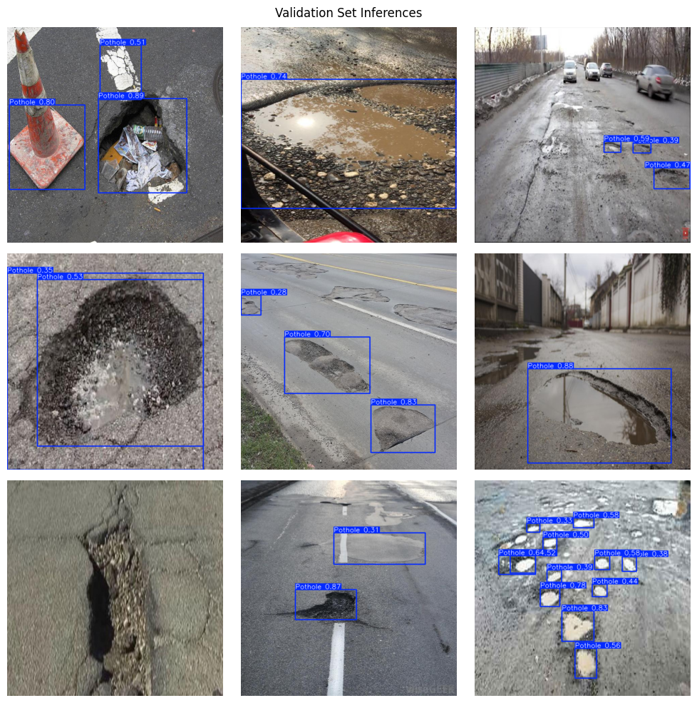

**Batch 0 preds:**

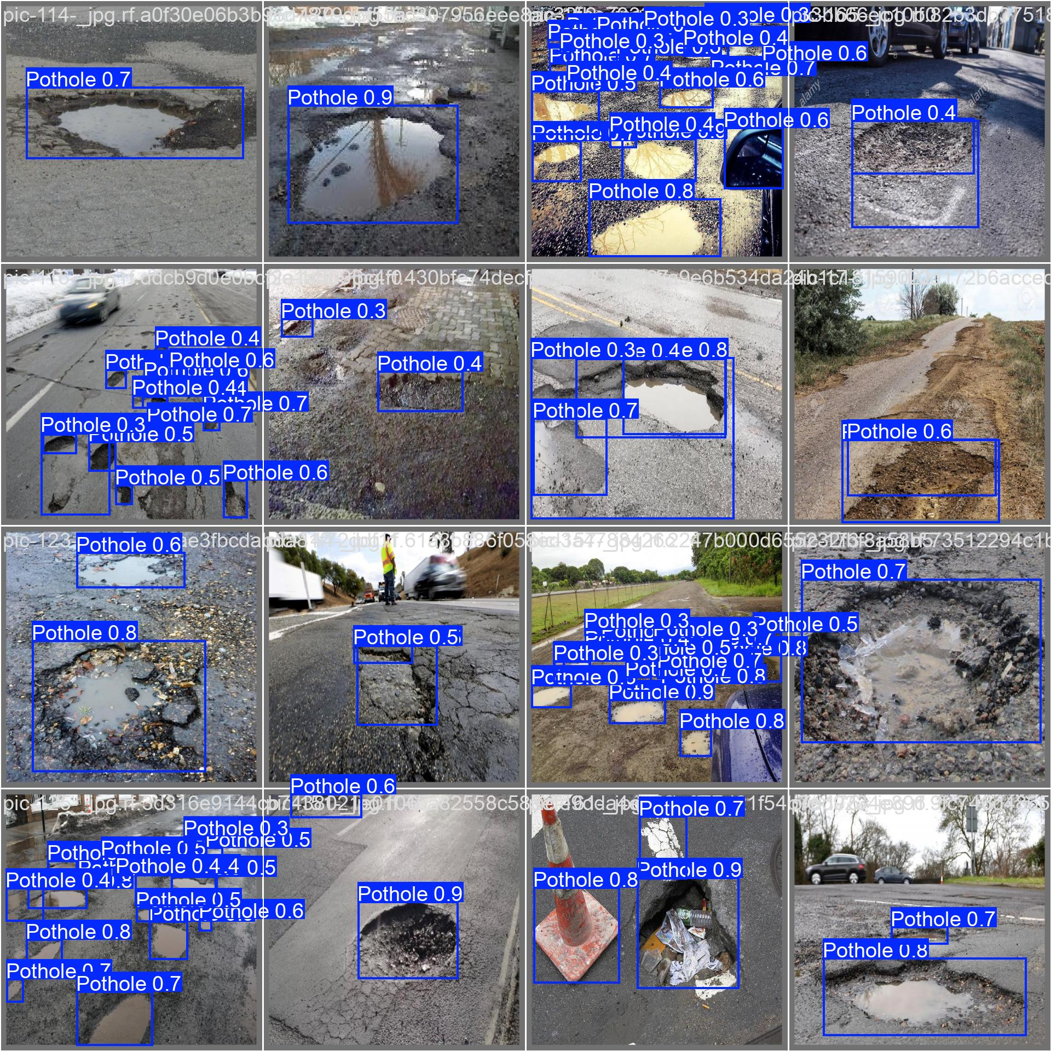

**Confusion matrix:**

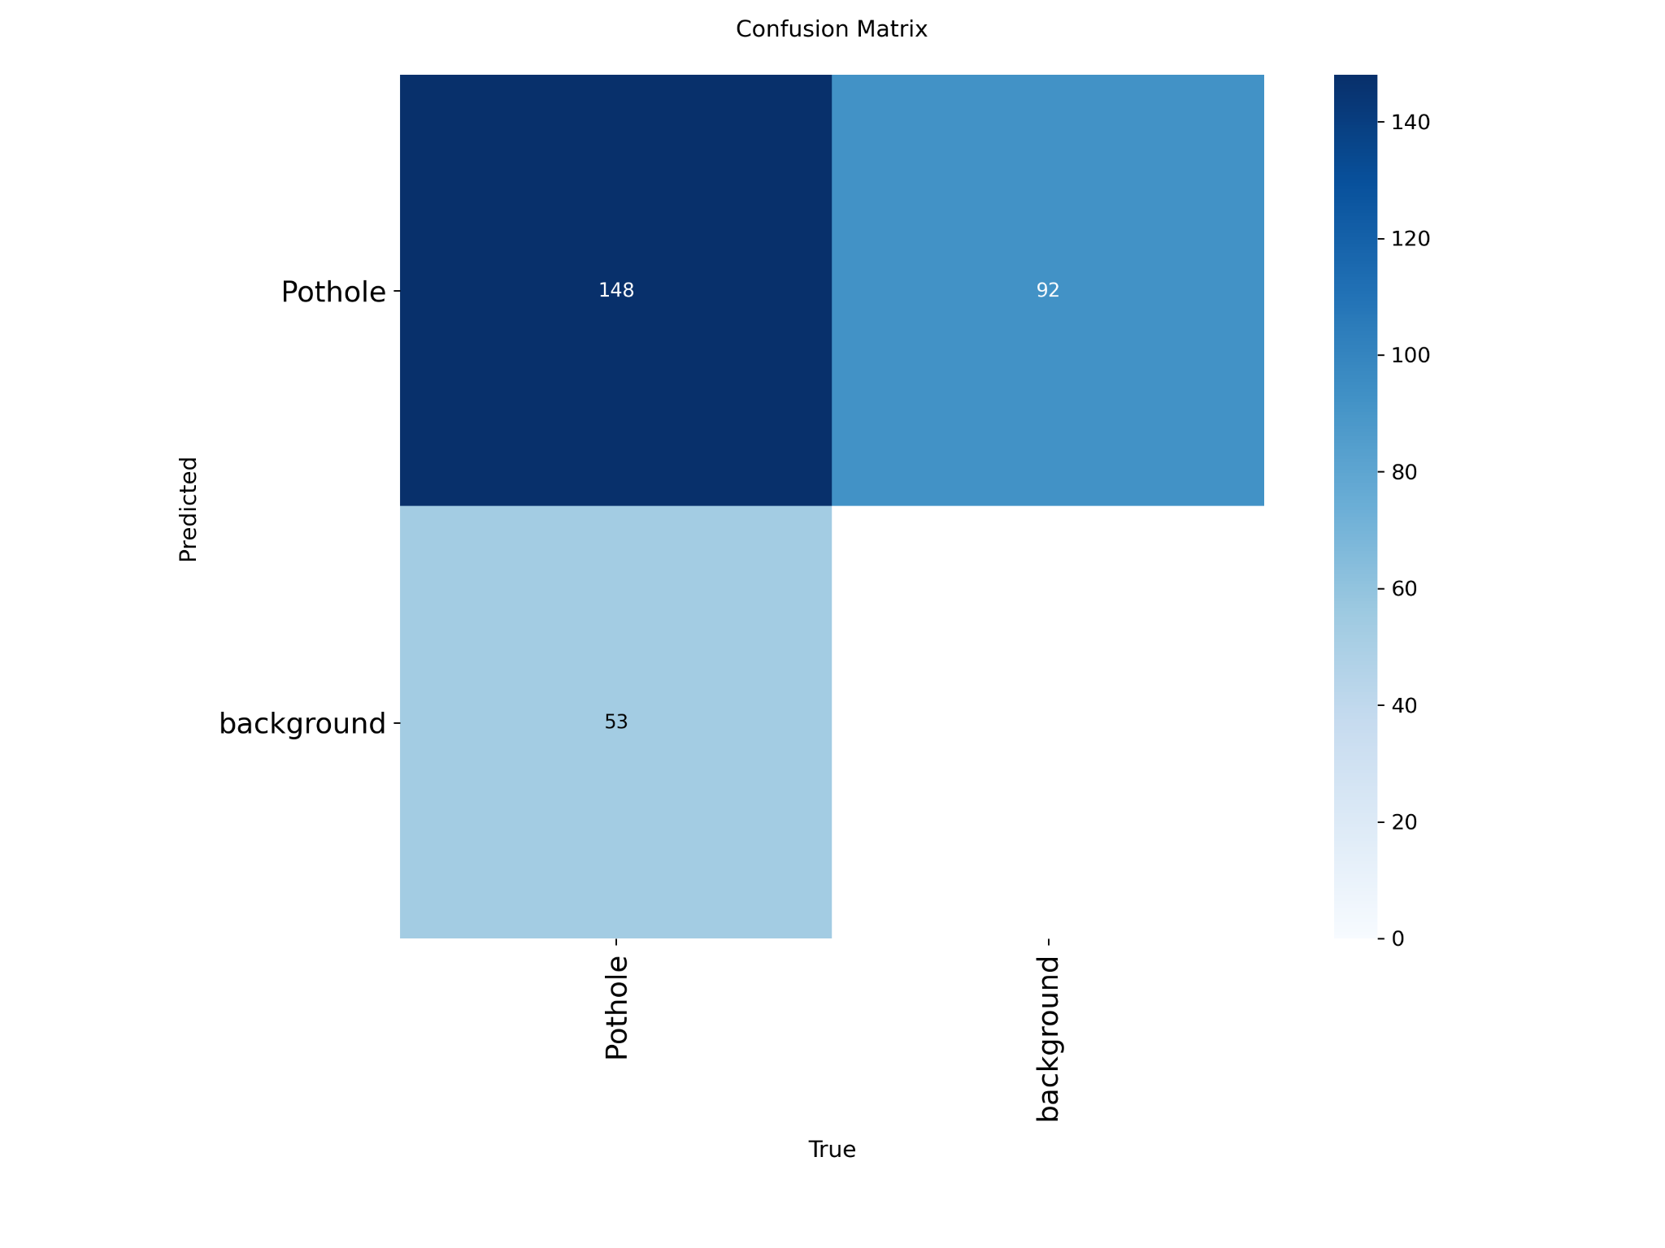

**Medium:**

**Random preds:**

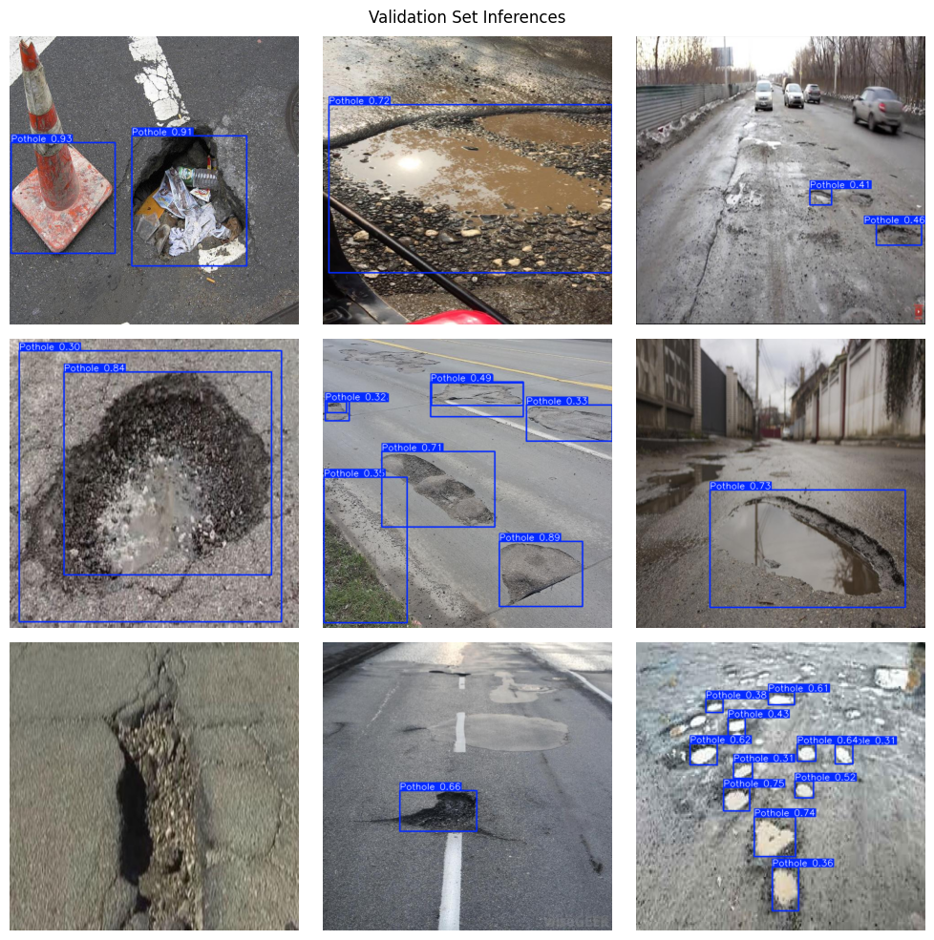

**Batch 0 preds:**

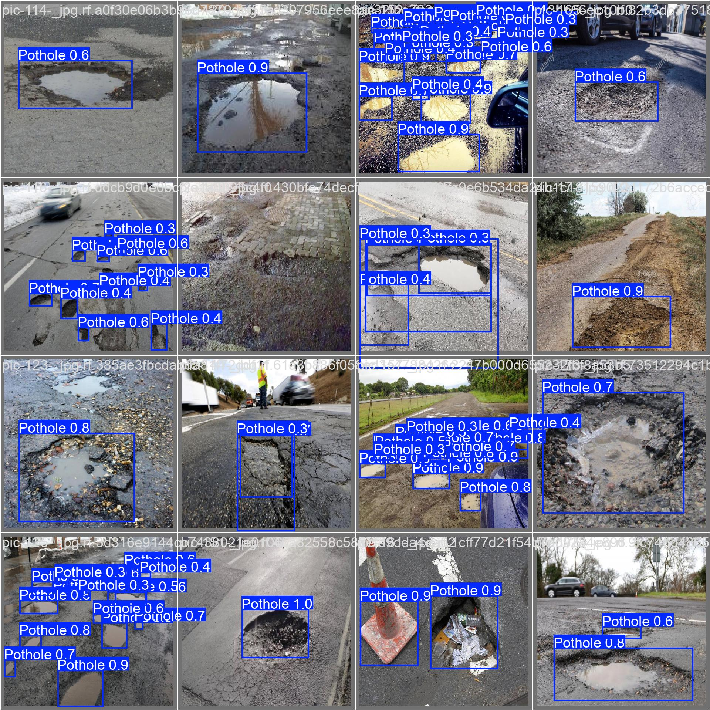

**Confusion matrix:**

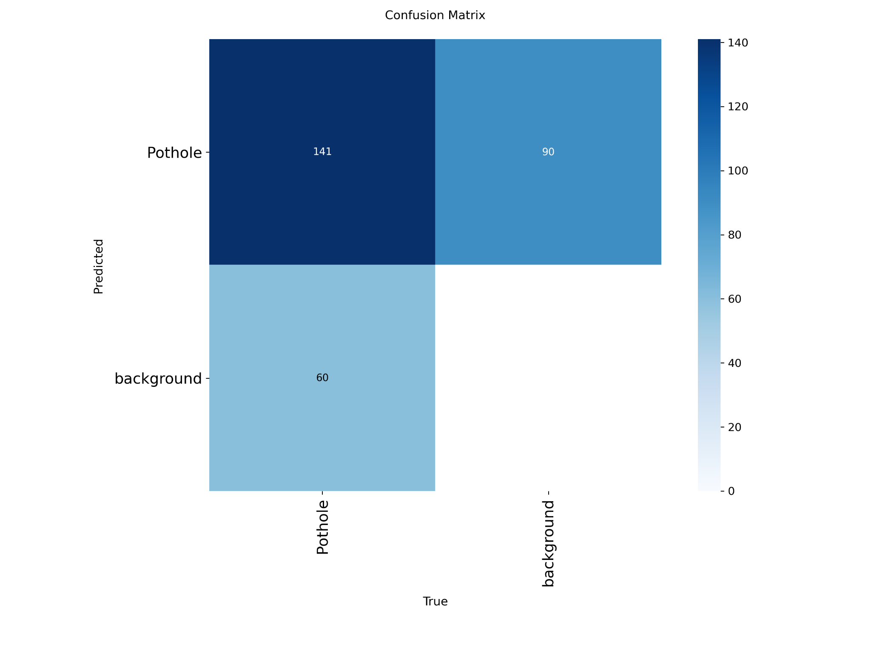

**Large:**

**Random preds:**

**Batch 0 preds:**

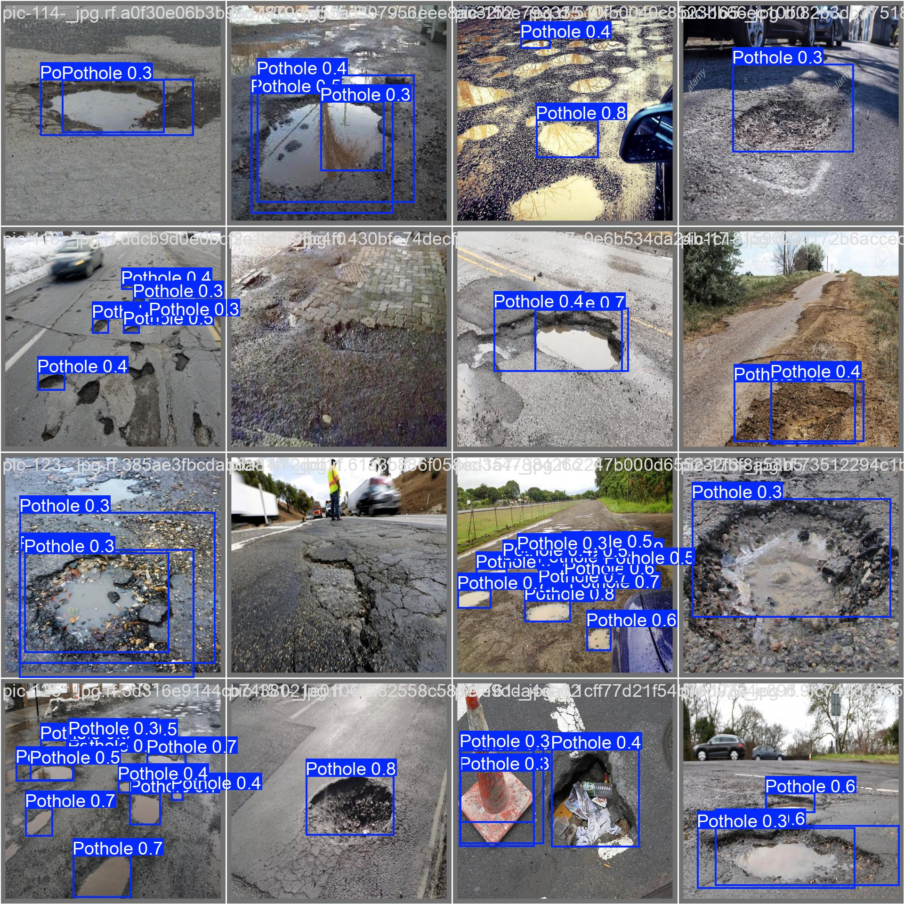

**Confusion matrix:**

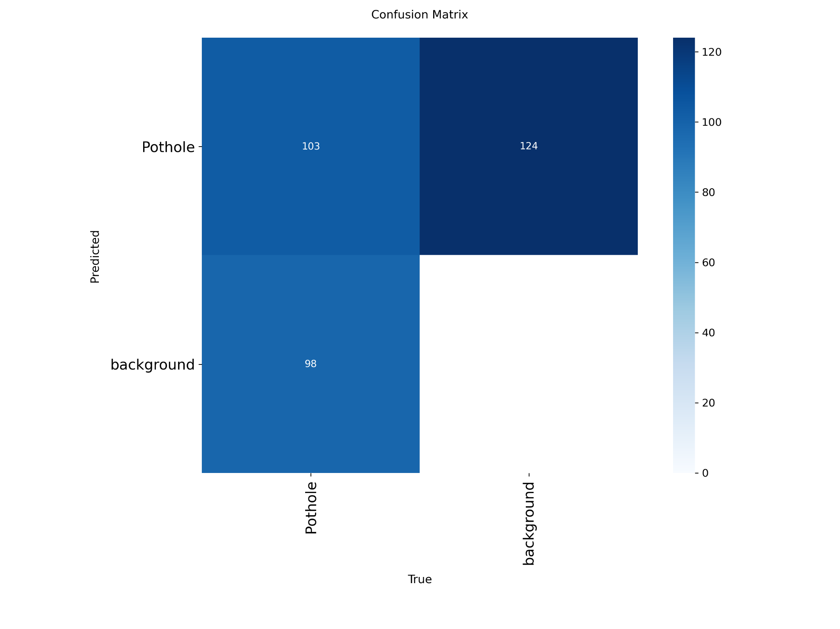

**X-Large:**

**Random preds:**

**Batch 0 preds:**

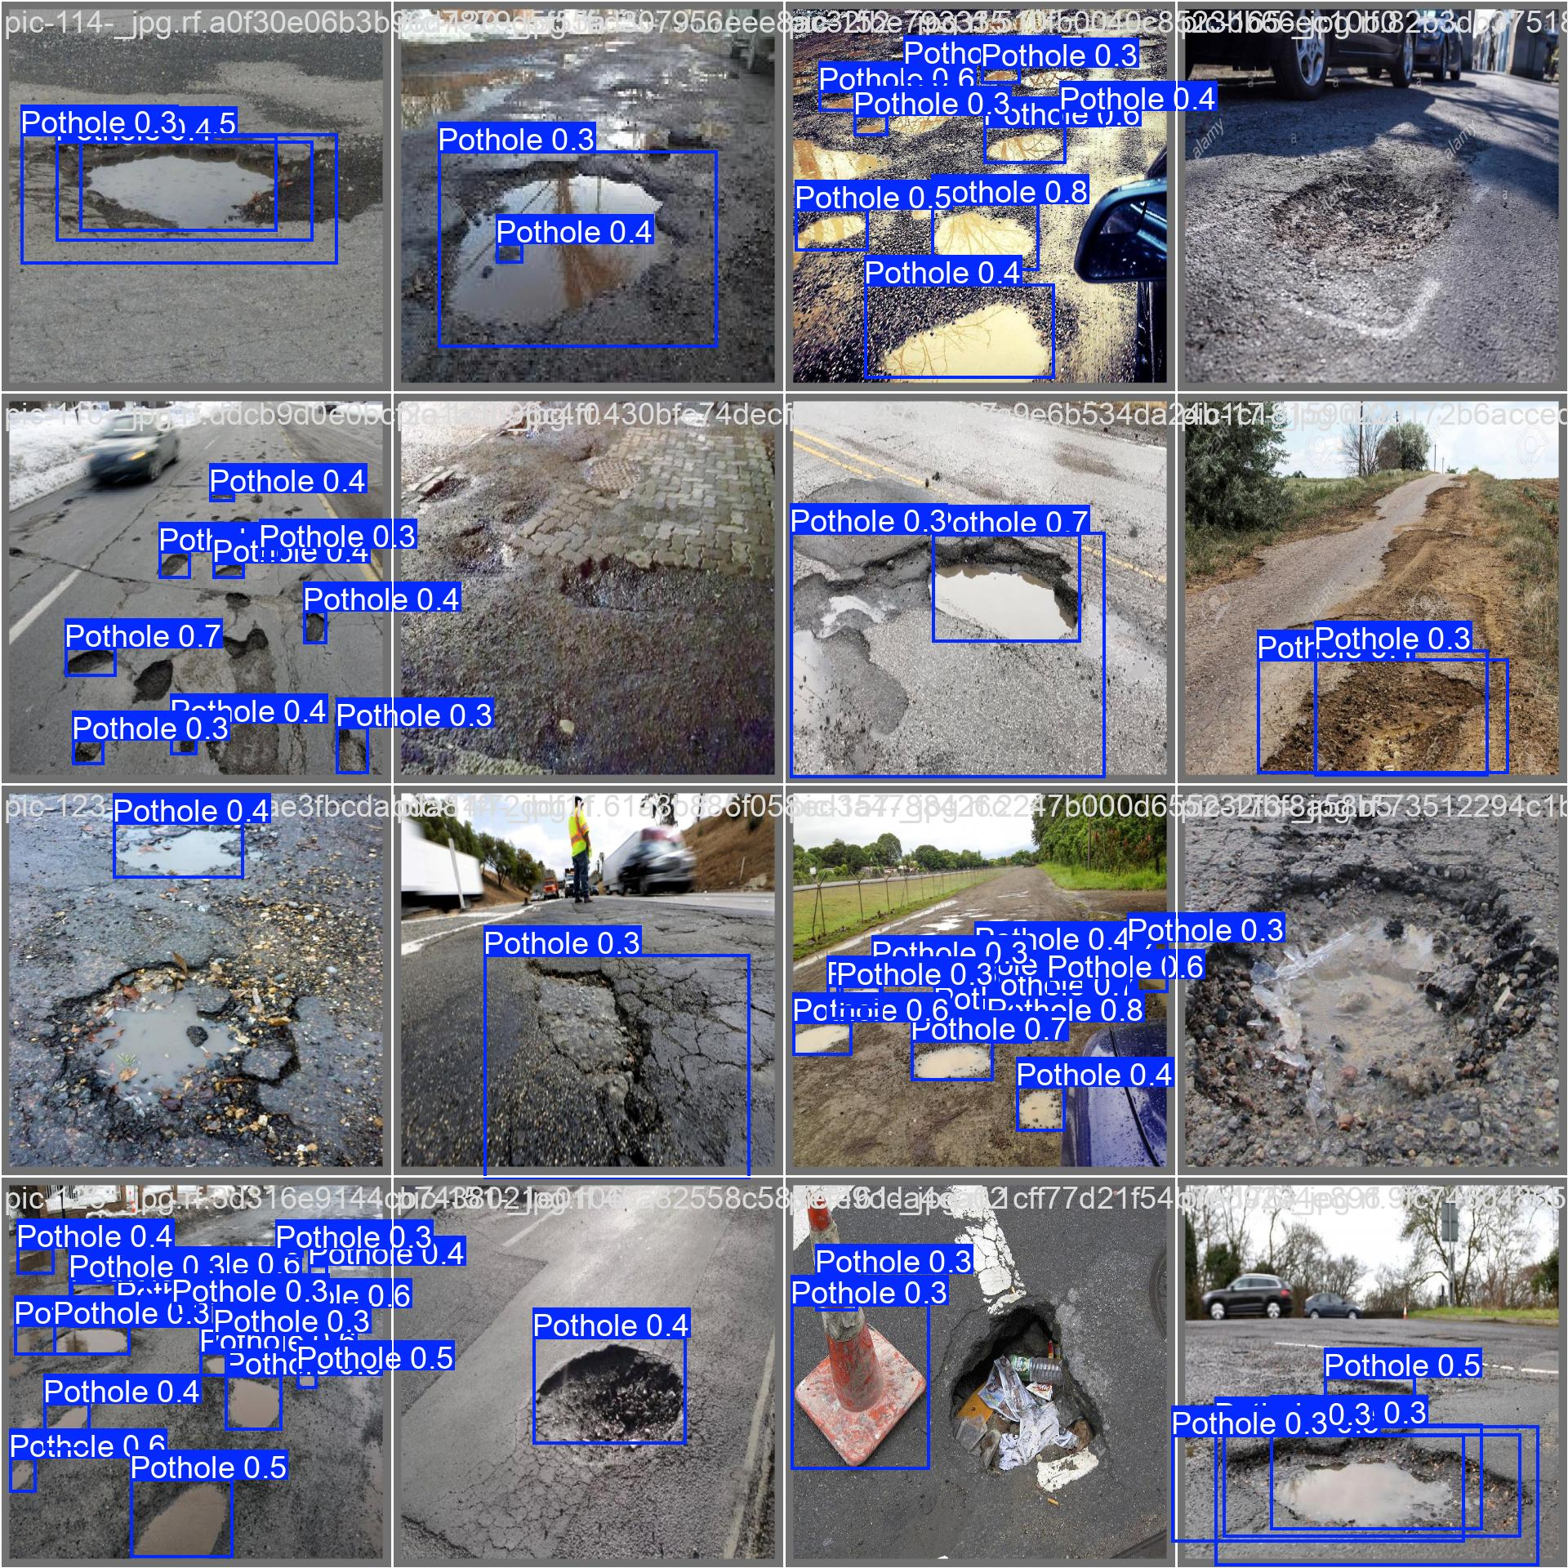

**Confusion matrix:**

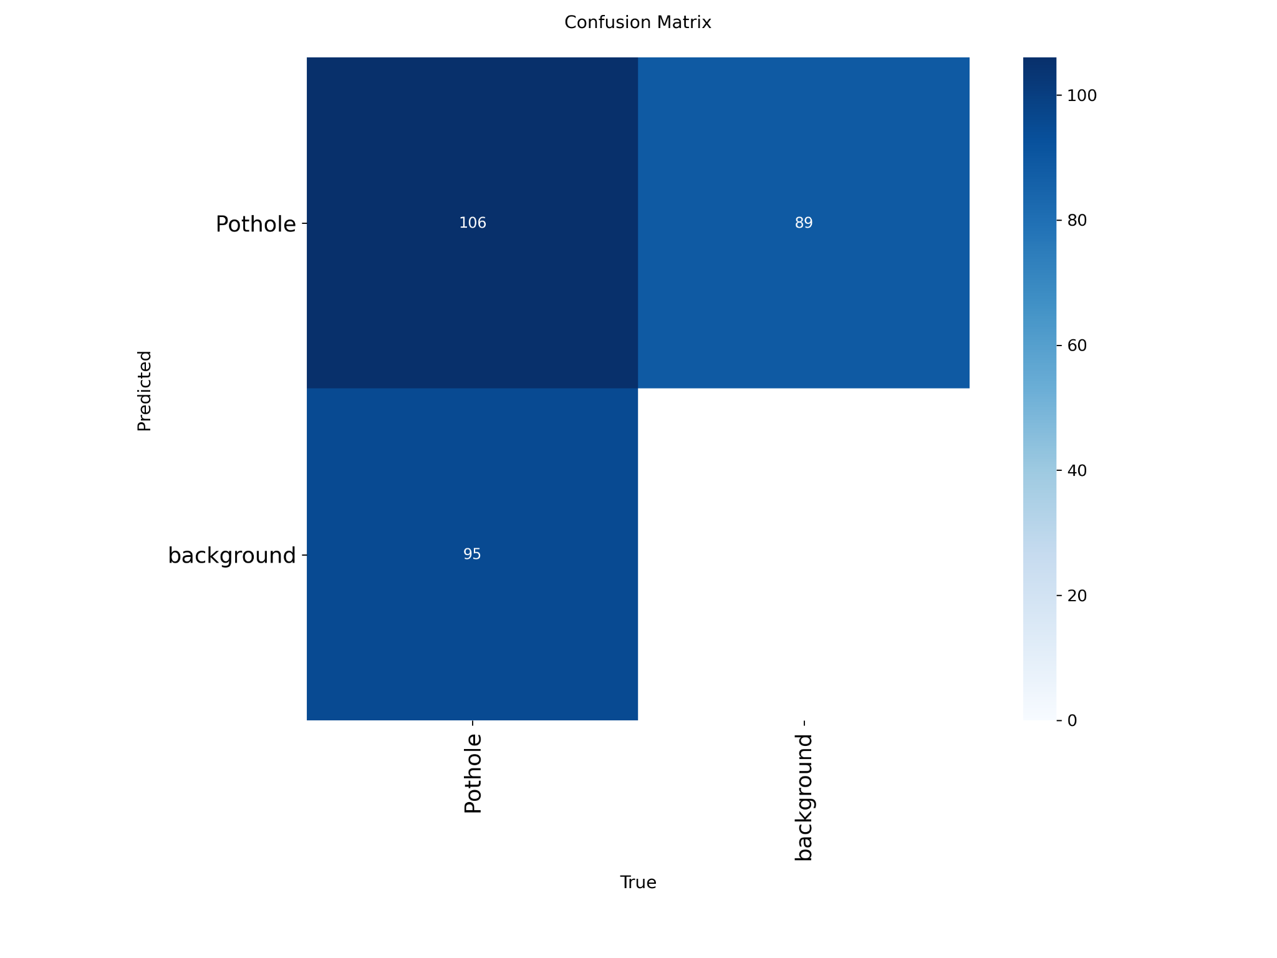

**Discussion:**

Between the **nano** and **small** models, there were no significant improvements in performance. While the **small** model achieved higher precision (0.74 vs. 0.656) and was able to detect more potholes, it also introduced more false positives, which ultimately reduced confidence in its predictions compared to the nano. This behavior is reflected in the images, the confusion matrix, and particularly in the recall metric.

Surprisingly, as the model size increased further (**medium, large, xlarge**), the results became worse. Initially, it was suspected that this was due to the small number of training epochs. However, even after training the **large** model for 25 epochs, its performance only approached that of the **medium** model.

This outcome can be explained by the fact that the dataset is relatively small, while larger models with higher complexity require substantially more training data to properly fit their massive number of parameters. In other words, the dataset is insufficient to effectively train such large networks, leading to overfitting or underperformance.

Therefore, in this case, the **nano** model strikes the best balance between accuracy and generalization. The trend also highlights another key point: larger models demand significantly more computational resources and training time, which makes them less practical when the dataset size does not justify their use.

1. Bonus: Pick and use a Yolo dataset from the Internet, re-run the code and show the results and draw your own conclusions. **Alejandro**

For this exercise we selected the following license plate dataset from kaggle.

Source: <https://www.kaggle.com/datasets/fareselmenshawii/license-plate-dataset>

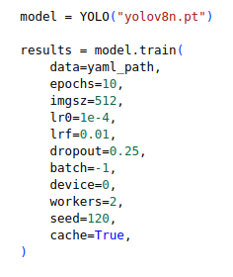

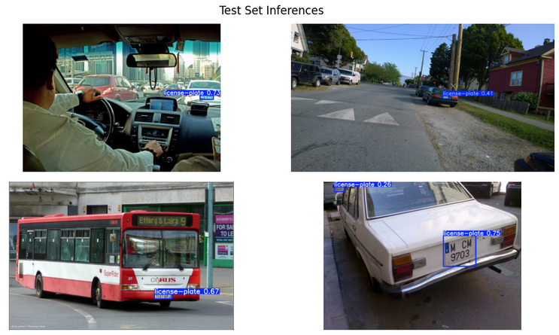

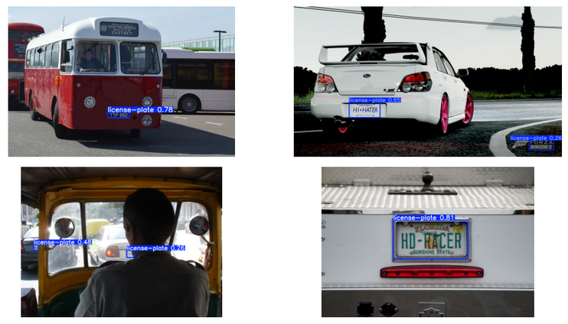

**Confusion matrix**

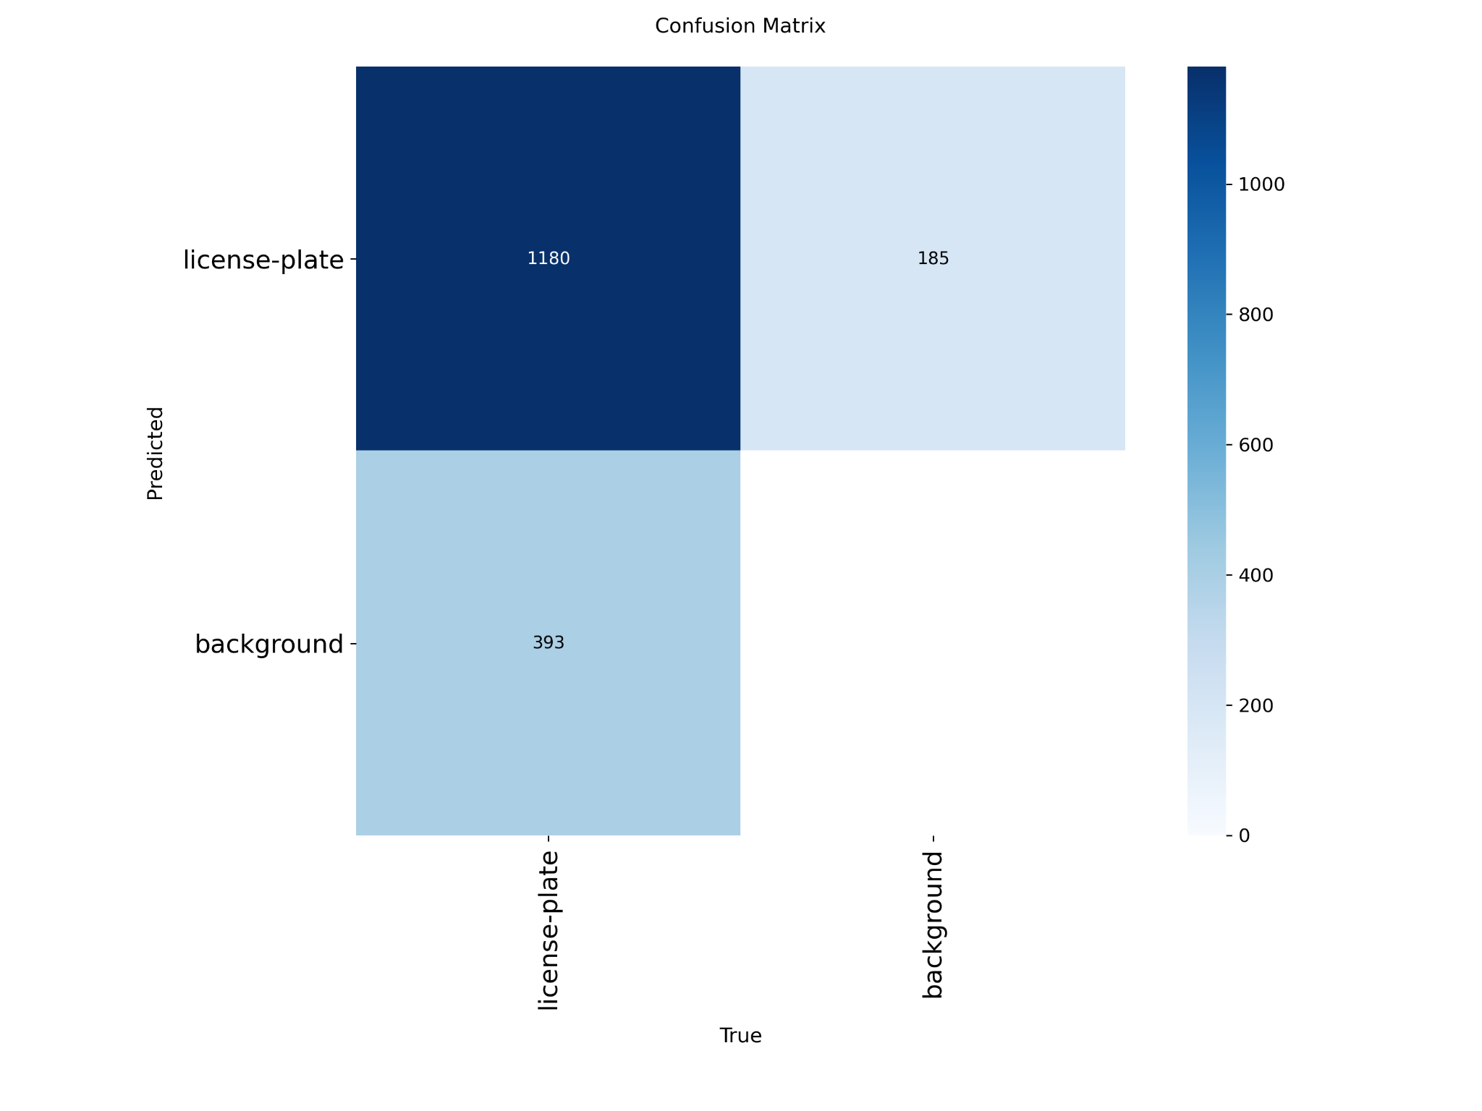

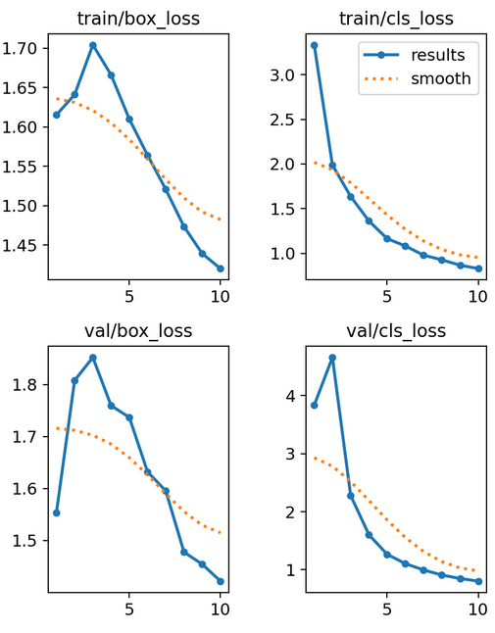

After training YOLOv8 nano on the license plate dataset, the results show that the model successfully learned to detect plates in different scenarios, which is evidenced by the decreasing training and validation losses and a confusion matrix with a high proportion of correct predictions. Overall, the model has good performance, but it could be improved by using a larger YOLOv8 variant, the largest one had the better performance in previous test, but in this case nano was employed because of computational limitations, other improvements could be expanding the dataset with more diverse images, fine-tuning hyperparameters, and training for more epochs.

**Answer the following questions:** *(Parece que es más sencillo responder estas preguntas a partir del punto 1, utilizando las diferentes versi)*

1. Which model worked better?

In the set of experiments, the larger model **YOLOv8x** performed better overall. They were able to detect more objects with higher confidence, even in complex scenes that contained multiple cars and motorcycles.

1. Why do you think that specific model did a better job?

The larger models worked better because they have more parameters and deeper layers, which give them greater representational power. This allows them to capture finer details and distinguish between overlapping or distant objects. As a result, they tend to reduce false positives and provide more consistent detections. The tradeoff, however, is that they demand more computational resources compared to the smaller models.

1. What are the advantages of Yolo V8 over other Yolo Versions?

YOLOv8 introduces several improvements compared to earlier versions. It offers a more optimized architecture, which results in a better balance between accuracy and speed. Unlike previous versions, YOLOv8 natively supports detection, segmentation, and classification tasks within the same framework. It also provides greater flexibility for training on custom datasets and allows easy exportation to multiple deployment formats such as ONNX, TensorRT, and CoreML. Furthermore, improvements in the Non-Maximum Suppression (NMS) process reduce overlapping or duplicate detections.

1. Why Yolo is better than other image detection algorithms?

YOLO stands out because of its real-time performance, making it much faster than alternatives like R-CNN or Faster R-CNN. Its single-shot architecture processes the entire image in a single forward pass, significantly reducing latency. YOLO also offers a strong balance between speed and accuracy, which makes it suitable for practical applications such as video surveillance, autonomous driving, and mobile devices. Its adaptability to different model sizes further enhances its usability across diverse environments.

1. Can you segment images using Yolo? Which Version should I use?

Yes, YOLO can perform segmentation tasks. With YOLOv8-seg, you can not only detect objects but also extract their exact contours within an image.

1. Compare versions 1 to version 8 in a table.

| **Version** | **Year** | **Key Characteristics** | **Limitations** |
| --- | --- | --- | --- |
| YOLOv1 | 2016 | First real-time detector with a single neural network, single-pass detection. | Poor detection of small and overlapping objects. |
| YOLOv2 (YOLO9000) | 2017 | Improved accuracy with anchor boxes and multi-scale detection. Capable of detecting 9000 classes. | Continued to show poor performance on small objects |
| YOLOv3 | 2018 | Introduced Darknet-53 backbone with residual connections and multi-scale predictions. | Heavy model, slower on limited hardware. |
| YOLOv4 | 2020 | CSPDarknet53 backbone, advanced training (Bag of Freebies), and attention modules (Bag of Specials). | Computationally expensive, requiring strong GPUs. |
| YOLOv5 | 2020 | PyTorch implementation, easy training and deployment, wide community adoption. | Not an official release from original YOLO authors. |
| YOLOv6 | 2022 | Optimized for industrial/edge deployment, very efficient and fast. | Limited public documentation and adoption outside industry. |
| YOLOv7 | 2022 | Achieved state-of-the-art accuracy with extended architectures and re-parameterized convolutions. | Complex training pipeline and resource-intensive. |
| YOLOv8 | 2023 | Introduced anchor-free head, unified detection, segmentation, and classification; flexible export. | Larger models require powerful GPUs. |

Ultralytics. (2023). *YOLOv8 Documentation*. Ultralytics official docs. <https://docs.ultralytics.com>

https://viso.ai/computer-vision/yolo-explained/

**Want to know more? Read this paper:**

**Yolo V1**

<https://www.cv-foundation.org/openaccess/content_cvpr_2016/papers/Redmon_You_Only_Look_CVPR_2016_paper.pdf>